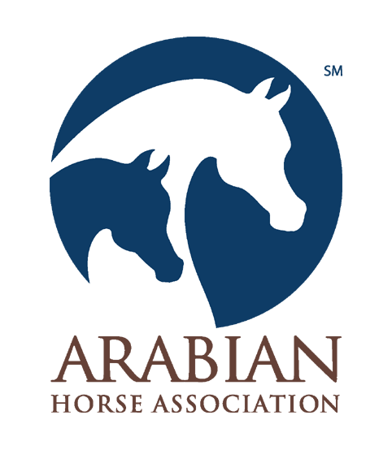
ARABIAN HORSE ASSOCIATION

OFFICER NOMINATION FORM

Dear AHA Members:

It is important that you avail yourselves of pertinent information about the various candidates who wish to be your officers in the coming years. To that end, the Nominating Committee presents this guideline form for those who self-nominate and present themselves to you.

By using these guidelines, we hope to have comparable information in sufficient detail for a side-by-side comparison, allowing you to confidently choose the candidate of your choice.

If you are a candidate, please use this form in a comprehensive, understandable way to give voting delegates the facts they need to make the most informed decision on your candidacy. If you are indeed a difference-maker, let your fellow delegates know it.

Sincerely,

AHA Nominating Committee: Peggy Weems, Chair; Laura Mickelson, Vice Chair; Diana Bein, Karen Caughell, Chase Harvill and Georgia Tachoires.

Please indicate which office you are seeking: President Vice President Treasurer Secretary

AHA Membership # Name

Current Club Affiliation (Name of Club) (Required)

Address E-Mail

City State/Prov. Zip/Postal

Home # Work # Fax #

Indicate your past and present role(s) in the AHA/Arabian Horse Industry:
Amateur – How many years Breeder – How many years
Exhibitor – How many years Judge/Steward – How many years
Owner – How many years Trainer/Professional – How many years
AHA Board Member – Which years AHA Committee Member – Which years
Club/Local/National/Regional Volunteer – Which years Club Officer – Which years
Delegate/Alternate – Which years Regional Officer – Which years

Personal and family data – include your work history, any special contributions to an industry outside of Arabian horses, articles you may have authored, academic achievements and any other accomplishments of which you are the most proud:

(Over)
Describe in detail your personal skills, knowledge or experience which would qualify you specifically for the office you seek:

Elaborate on your leadership abilities, giving specific examples, if possible, of previous situations in which you have participated as a leader successfully:

Demonstrate how your interpersonal abilities might help AHA in achieving its goals with the least cause for friction or loss of cohesiveness. Use life examples as you wish:

Describe your perspective of AHA problems, and solutions you would suggest as viable. Be as specific as you can:

Relate new proposals/objectives for AHA which you can assist in developing or implementing:

Horse-related activities of importance:

Any miscellaneous information that might distinguish you from other candidates:

AHA is a large corporation with inherent competitive, financial and administrative issues. Please support your abilities in regard to these items:

Please submit this completed form as a Microsoft Word document via e-mail to: Joleen.White@ArabianHorses.org no later than August 1

