AHASM Show Number
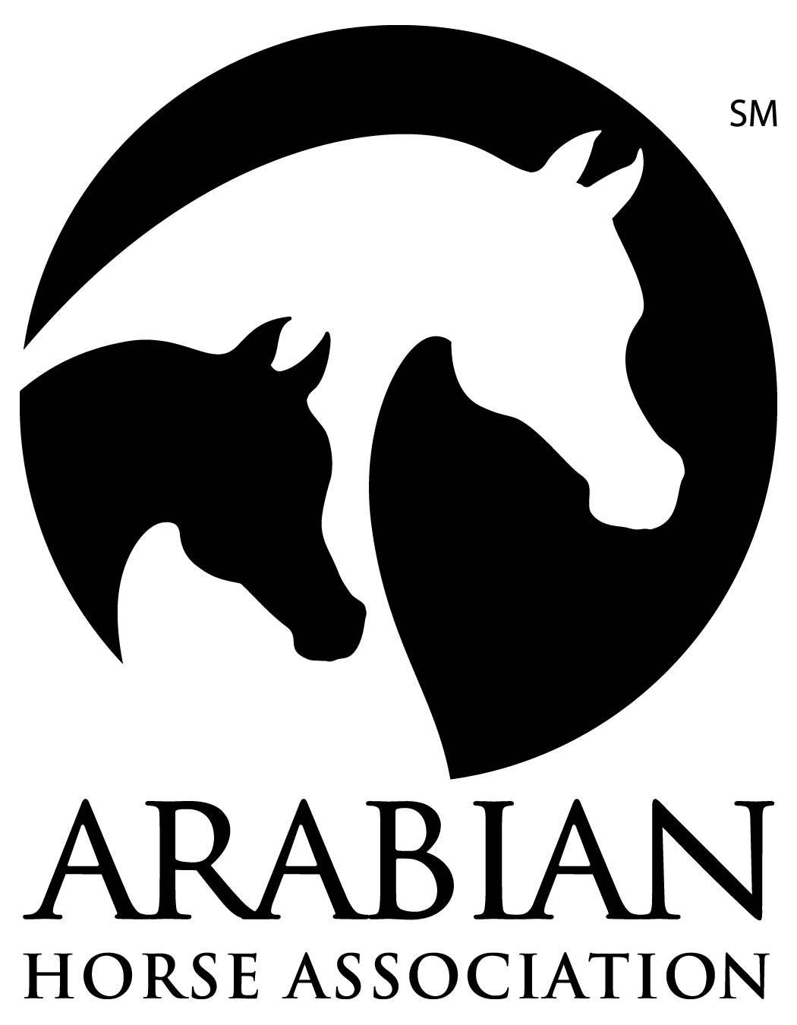

THE ARABIAN HORSE ASSOCIATIONSM
RECOGNIZES THE ARABIAN DIVISION OF THIS SHOW

Sponsored ByThe Arabian Horse Association

The Arabian Horse Association is a major equine association serving members in the United States and Canada. It registers and maintains a database of more than one million Arabian, Half-Arabian and Anglo- Arabian horses and administers more than $2.5 million in annual prize money. AHA produces championship events, recognizes over 375 Arabian horse shows and distance rides annually and provides activities and programs that promote breeding and ownership. For information about Arabian, Half-Arabian and Anglo-Arabian horses, call 303-696-4500, e-mail info@ArabianHorses.org or visit ArabianHorses.org

All Arabian/Half-Arabian/Anglo-Arabian exhibitors entered in this event must be a current AHA member with a Competition Card or pay a Single Event Membership fee per person. This includes any owner, trainer, driver, rider, or halter handler who exhibits horses in the show ring or signs the entry form as the responsible person for any individual's horse.

To join the
(Insert club name, if an AHA affiliate)

please contact
(Insert Secretary or Membership Chair name)

(Address of Secretary or Membership Chair)
Contributions or gifts to AHA are not tax deductible as charitable contributions. However, they may be deductible as ordinary and necessary business expenses if so advised by appropriate tax counsel.
Join AHA through your local club for the following great member benefits:
- Reduced rate for competition privileges across a variety of disciplines for local, regional and national AHA-approved shows and rides
- Peace of mind with 1 million in personal liability insurance through Equisure
- Preferred rates on horse registrations and transfers
- Preferred rates on ArabDataSource, the world’s largest online Arabian horse resource
- Numerous opportunities to participate in award recognition and prize money programs
- Show circuits for AHA members at local, regional and national levels

The Judges & Stewards Commissioner is responsible for handling written and signed complaints relating to judges' and stewards' conduct when filed by exhibitors, show officials, AHA members or others, and when accompanied by a filing fee [Resolution 5-90]. Other comments, compliments, questions, inquiries are encouraged when appropriate (no filing fee required). Write: Judges & Stewards Commissioner, 6030 Greenwood Plaza Blvd., Suite 100, Greenwood Village, CO 80238 (303) 696-4539.

AHA 090031 (Rev. 2/23)

AHASM Show Number

tHE ARABIAN HORSE ASSOCIATIONSM
RECOGNIZES the arabian division
OF THIS SHOW

Sponsored By

AHA is the promotional and coordinating organization for Arabian, Half-Arabian and Anglo-Arabian horse activities in the United States and Canada. AHA consists of nearly 40,000 individual members in almost 265 affiliated clubs. Members can transact business with AHA online at www.ArabianHorses.org. Several member benefits include the following: reduced fees for registering Arabian, Half-Arabian and Anglo-Arabian foals; membership decal; a subscription to the Modern Arabian Horse magazine, showing privileges for all AHA recognized shows; ability to become involved in AHA programs, such as the Arabian Breeders Sweepstakes, futurities and AHA awards programs; as well as all AHA national championship horse shows.

All exhibitors entered in this event must be a current AHA member with a Competition Card or pay a Single Event Membership fee of $10.00 per person. This includes any owner, trainer, driver, rider, or halter handler who exhibits horses in the show ring or signs the entry form as the responsible person for any individual's horse.

To join the
(Insert club name, if an AHA affiliate)

please contact
(Insert Secretary or Membership Chair name)

(Address of Secretary or Membership Chair)

Contributions or gifts to AHA are not tax deductible as charitable contributions. However, they may be deductible as ordinary and necessary business expenses if so advised by appropriate tax counsel.

If you wish to join the Arabian Horse Association, please send $75.00 for an Adult membership with a Competition Card; $55.00 for a Business membership; or $30.00 for a Youth membership with a Competition Card (if under the age of eighteen as of December 1st of the previous calendar year). You can also join AHA online at www.ArabianHorses.org. Membership renewals postmarked to the AHA office after the last day of the month in which the previous membership expired will be assessed a $10.00 late fee. These fees should be sent to AHA, 10805 E. Bethany Dr., Aurora, CO 80014-2605. (Add 7% GST for Canadian Residents to all membership fees listed above)

The Judges & Stewards Commissioner is responsible for handling written and signed complaints relating to judges' and stewards' conduct when filed by exhibitors, show officials, AHA members or others, and when accompanied by a ten-dollar ($10.00) filing fee [Resolution 5-90]. Other comments, compliments, questions, inquiries are encouraged when appropriate (no filing fee required). Write: Judges & Stewards Commissioner, 6030 Greenwood Plaza Blvd., Suite 100, Greenwood Village, CO 80238 (303) 696-4539

AHA 090031 (Rev. 2/23)

AHASM Show Number

tHE ARABIAN HORSE ASSOCIATIONSM
RECOGNIZES THE ARABIAN DIVISION OF THIS SHOW

Sponsored By

AHA is the promotional and coordinating organization for Arabian, Half-Arabian and Anglo-Arabian horse activities in the United States and Canada. AHA consists of nearly 40,000 individual members in almost 265 affiliated clubs. Members can transact business with AHA online at www.ArabianHorses.org. Several member benefits include the following: reduced fees for registering Arabian, Half-Arabian and Anglo-Arabian foals; membership decal; a subscription to the Modern Arabian Horse magazine, showing privileges for all AHA recognized shows; ability to become involved in AHA programs, such as the Arabian Breeders Sweepstakes, futurities and AHA awards programs; as well as all AHA national championship horse shows.

All exhibitors entered in this event must be a current AHA member with a Competition Card or pay a Single Event Membership fee of $10.00 per person. This includes any owner, trainer, driver, rider, or halter handler who exhibits horses in the show ring or signs the entry form as the responsible person for any individual's horse.

To join the
(Insert club name, if an AHA affiliate)

please contact
(Insert Secretary or Membership Chair name)

(Address of Secretary or Membership Chair)

Contributions or gifts to AHA are not tax deductible as charitable contributions. However, they may be deductible as ordinary and necessary business expenses if so advised by appropriate tax counsel.

If you wish to join the Arabian Horse Association, please send $75.00 for an Adult membership with a Competition Card; $55.00 for a Business membership; or $30.00 for a Youth membership with a Competition Card (if under the age of eighteen as of December 1st of the previous calendar year). You can also join AHA online at www.ArabianHorses.org. Membership renewals postmarked to the AHA office after the last day of the month in which the previous membership expired will be assessed a $10.00 late fee. These fees should be sent to AHA, 10805 E. Bethany Dr., Aurora, CO 80014-2605. (Add 7% GST for Canadian Residents to all membership fees listed above)

The Judges & Stewards Commissioner is responsible for handling written and signed complaints relating to judges' and stewards' conduct when filed by exhibitors, show officials, AHA members or others, and when accompanied by a ten-dollar ($10.00) filing fee [Resolution 5-90]. Other comments, compliments, questions, inquiries are encouraged when appropriate (no filing fee required). Write: Judges & Stewards Commissioner, 6030 Greenwood Plaza Blvd., Suite 100, Greenwood Village, CO 80238 (303) 696-4539

AHA 090031 (Rev. 2/23)

